**Jerk Chicken Recipe**

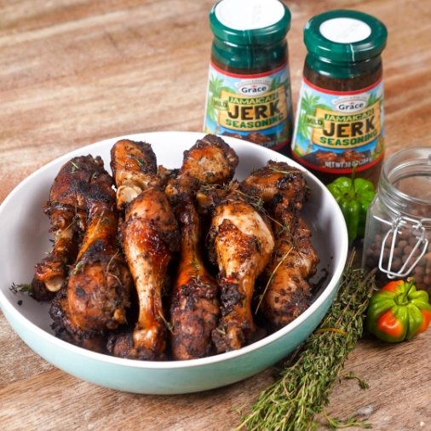

**INGREDIENTS**

15 drumsticks

3 tbsp Grace Jerk Seasoning

1 tbsp soy sauce

6 cloves garlic minced

1 scotch bonnet pepper

1 tbsp sugar

4 sprigs fine thyme

2 tbsp pimento/ juniper berries or all spice powder

3 tbsp vegetable oil

**METHOD:**

Add pimento/ juniper berries to a spice grinder then grind to a fine powder.

Add garlic, pepper, thyme, sugar to a mortar and pestle or food processor then grind into a paste.

Add soy sauce and vegetable oil to paste then combine.

Place drumstick in a large bowl then add Grace Jerk Seasoning, all spice powder and the paste.

Rub drumsticks with mixture making sure all pieces are well coated.

All to marinate for at least two hours. It is best to leave it overnight.

### Cook the chicken:

* Grilling method: Preheat grill over medium high heat to 425-450°F. Grill the chicken 8-10 minute per side, or until desired doneness. (see note 2)
* Baking method: Preheat oven to 400°F. Bake chicken on a lightly oiled sheet pan or baking dish for about 1 hour, or until desired doneness. (see note 2)

**Notes**

* 1. 1 pepper for mild, 2 for medium hot and 3 for extra hot

Chicken is safe to eat at 165°F. This is also the ideal doneness for chicken breast. For chicken thighs or legs, use the following guidelines:  
- 165°F chicken is done, but is still chewy and sticks to the bone.  
- 175-180°F for chicken that is tender, but sticks to the bone.  
- 185-190°F for chicken that is tender and falls off the bone.